Assignment # 6

# Eric Dockery 12/03/13

1. Programming project 11.1 of Chapter 11
2. Programming project 11.2 of Chapter 11
3. Programming project 11.5 of Chapter 11

Programming Project 11.1

Description:

Design and implement a program that creates an exception class called StringTooLongException, designed to be thrown when a string is discovered that has too many characters in it. In the main driver of the program, read strings from the user until the user enters “DONE.” If a string is enetered that has too many characters (say 20), throw the exception. Allow the thrown exception to terminate the program.

How to solve:

First I need to create the StringTooLongException Class extends exception. Then I will create the Driver class that will take in strings from the user until “DONE” is submitted. Each string will be checked to see if it has more than 20 characters and if it does it will throw the exception.

Screen Shots:

(A good line and a line past 20 characters)

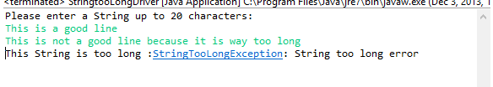

(A good line and “DONE” break)

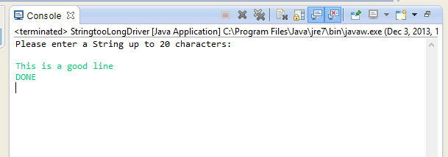

Programming Project 11.2

Description:

Modify the solution to PP 11.1 such that it catches and handles the exception if it is thrown. Handle the exception by printing an appropriate message, and then continue processing more strings.

How to Solve:

For the StringTooLongException program I will remove the line of code **super(“String too long error”);** I will then add a line to the catch that will call the main(args)after the exception.

Screen Shots:

(A good String, A string calling the Exception then running a good string, then terminated by DONE)

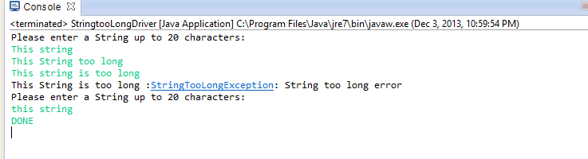

Programming Project 11.5

Description:

Modify the DisplayFile program from Chapter 10 to add a button labeled Save above the text area. When the button is pushed, write the contents back out to the file.

How to Solve:

Copy the DisplayFile program from Chapter 10. Add the Save button above the text area. The only issue with this is getting the action listener for the Save button to work for some reason I was receiving an error when adding the new ActionListener. Then I had problems correctly making the output that information to the file.

Screen Shots:

(program running)

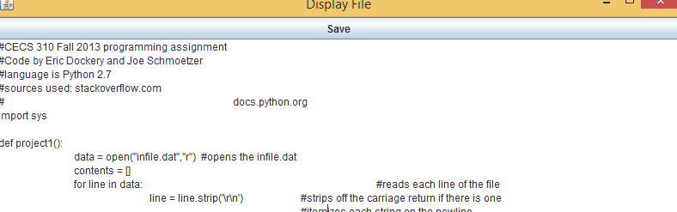

(First Save attempt)

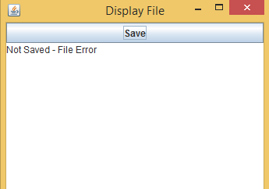

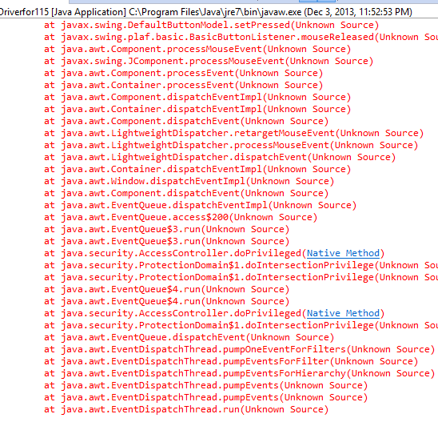

(Second Save Attempt location of file wasn’t passed correctly)



** couldn’t figure out how to make the file name go back into my saved program. Worked on it for about 2.5 hours getting the same result. Of file == null, but no errors.